Name: ______________________ Class: ______ Time: 30 minutes Total Mark:____/25
Year 9

Mini Test

Show working and answers on this sheet. Show working in sufficient detail to support your answers. Incorrect answers without supporting reasoning may be allocated zero marks.

1 A4 Notes & Calculator Allowed

Question 1 2 marks

Simplify these ratios:

- 15 : 5 ii) 1.8 : 1.5


Question 2 1 marks

A mixed netball team has 4 boys and 7 girls. What is the ratio of boys to girls?

________________________________________________________________________

Question 3 2 marks

Express as a ratio and simplify:

- 300g to 1000g ii) 1.4m to 70cm

Question 4 1 marks

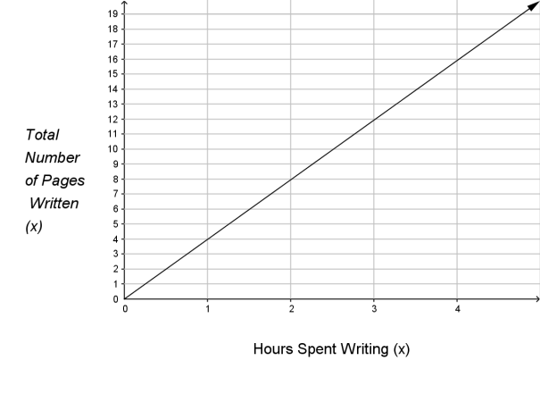
Look at the graph on the left. The total number of pages written is proportional to the number of hours spent writing (circle an answer):

- True ii) False

Question 5 2 marks

Which of the following pairs of ratios are in proportion?

  - 6:2 and 12:4 _____________________

  - 90cm at 8 years old and 1.45m at 12 years old: ___________________

Question 6 4 marks

Rodrigo can walk 5km in 30 minutes:

- Draw a graph to represent this information.

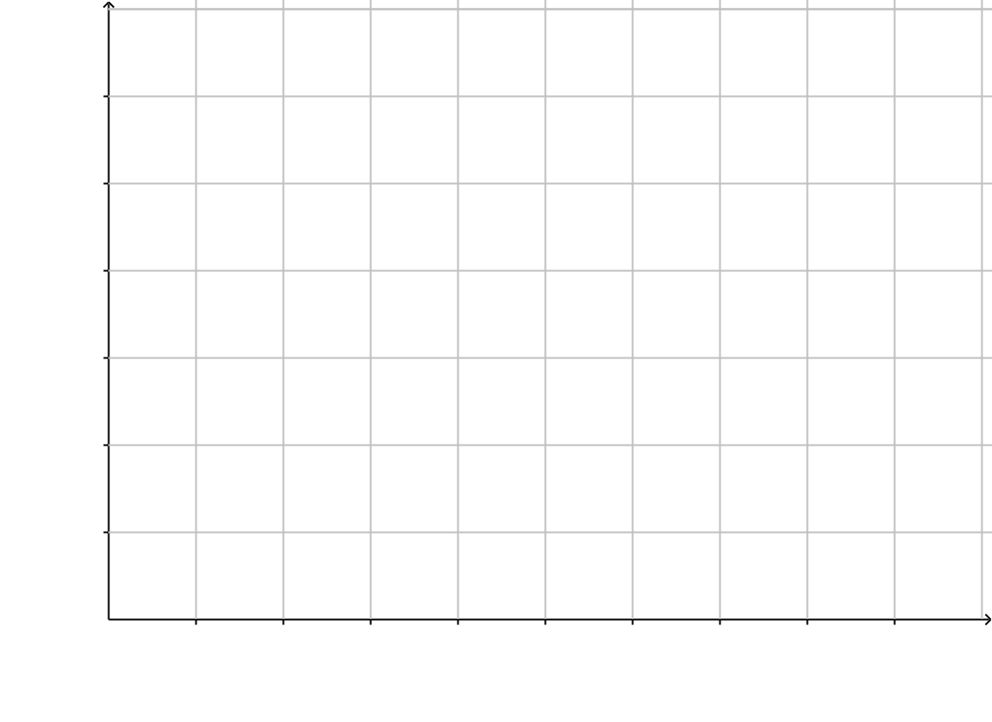
- Write a rule for Rodrigo’s journey.

Question 7 4 marks

Assuming direct proportionality. If $AU1 can be exchanged for $US1.09:

- How many Australian dollars can be exchanged for $US500?

- How many US dollars can be exchanged for $AU900?

Question 8 2 marks

If 8 people can build a house in 20 days, assuming inverse proportionality, how long would it take 20 people to build the same house?

Question 9 5 marks

The following graph represents the fuel consumption of a regular truck:

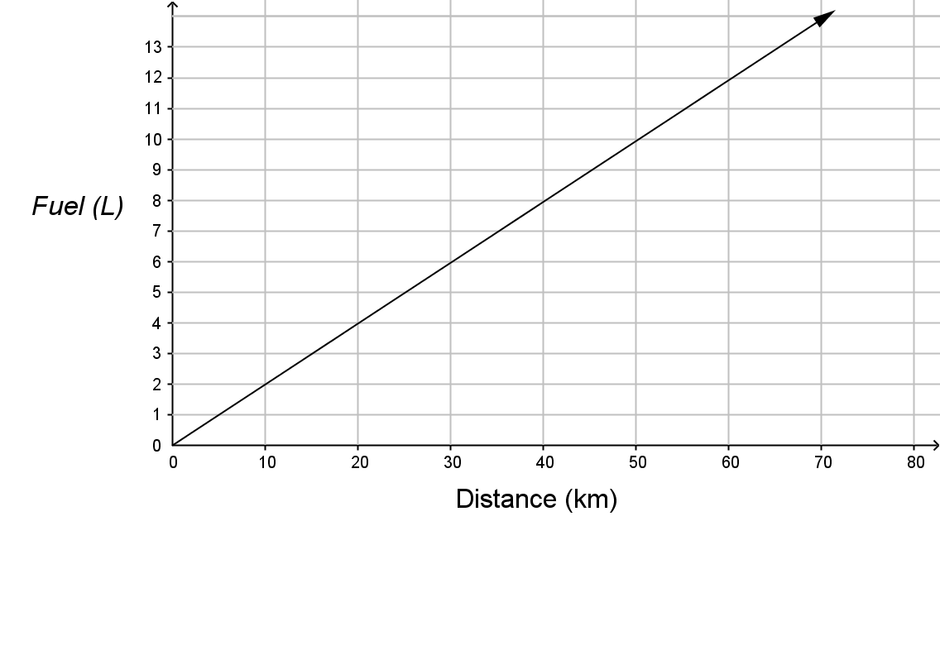

- How far can the truck go on 10L of fuel?

- How much fuel is required to go 1km?

- What is the rule?

- Using your rule how much fuel would be needed to travel 200km?

Question 10 2 marks

If 1 kilogram of bananas cost $4.00:

- What is the cost of 6kg?

- How much bananas for $9.25?

END OF TEST

